**Software Testing Assignment Module 1**

**Q1.** What is SDLC.

**Ans.** SDLC is a structure imposed on the development of a software product that defines the process for planning, implementation, testing, documentation, deployment, and ongoing maintenance.

**Q2.** What is agile methodology?

**Ans.** Agile SDLC model is a combination of iterations and incremental process model with focus on process delivery and customer satisfaction by rapidly deliver of product.

**Q3.** What is SRS.

**Ans.**

**Q4.** What is oops.

**Ans.** OOPs is known as object-oriented programming system.

**Q5.** Write Basic Concepts of oops

**Ans**. OOPs is known as object-oriented programming system. The basic concept of OOPs is to identifying objects and assigning responsibilities to these objects and manipulate these objects to get results.

**Q6.** What is object.

**Ans.** Object is an instance of a class, to create a memory for that class, using new keyword to create memory for that class, to access all the variable or method via object except private.

**Q7**. What is class

**Ans.** Class is a collection of data member (variables) or member functions (process, method) with its behaviour.

**Q8.** What is Encapsulation?

**Ans.** Data hiding: wrapping up of data into single unit i.e. Private your data member or member function.

**Q9.** What is inheritance?

**Ans.** Properties of parent’s class extends into child class. Properties of super class extends into sub-class. Main purpose is Reusability, Extendibility.

**Q10.** What is polymorphism?

**Ans.** Ability to take one name having different form, there are 2 types

1. Compile time: - Method overloading
2. Run time: - Method overriding

**Q11.** What is RDBMS

**Ans.** RDBMS is known as Relational Database Management system. RDBMS is a database managements system that is based on relational model.

**Q12.** What is SQL

**Ans.** SQL is known as structured Query Language to storing in permanent medium.

**Q13.** Write SQL Commands

**Ans.** SQL commands

1. DDL: - Data definition language
2. DML: - Data manipulation language
3. DCL: - Data control language
4. DQL: - Data query languag

**Q14.** Draw Use-case on Online book shopping

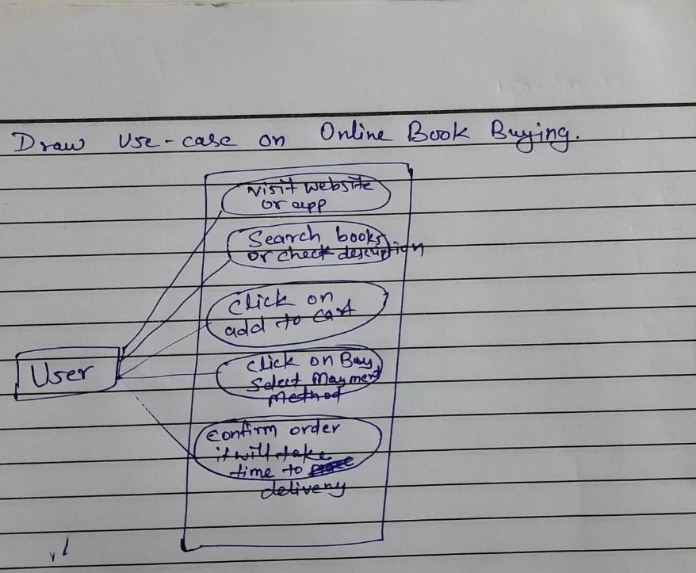  
**Q15.** Draw Use-case on online bill payment system (Paytm)

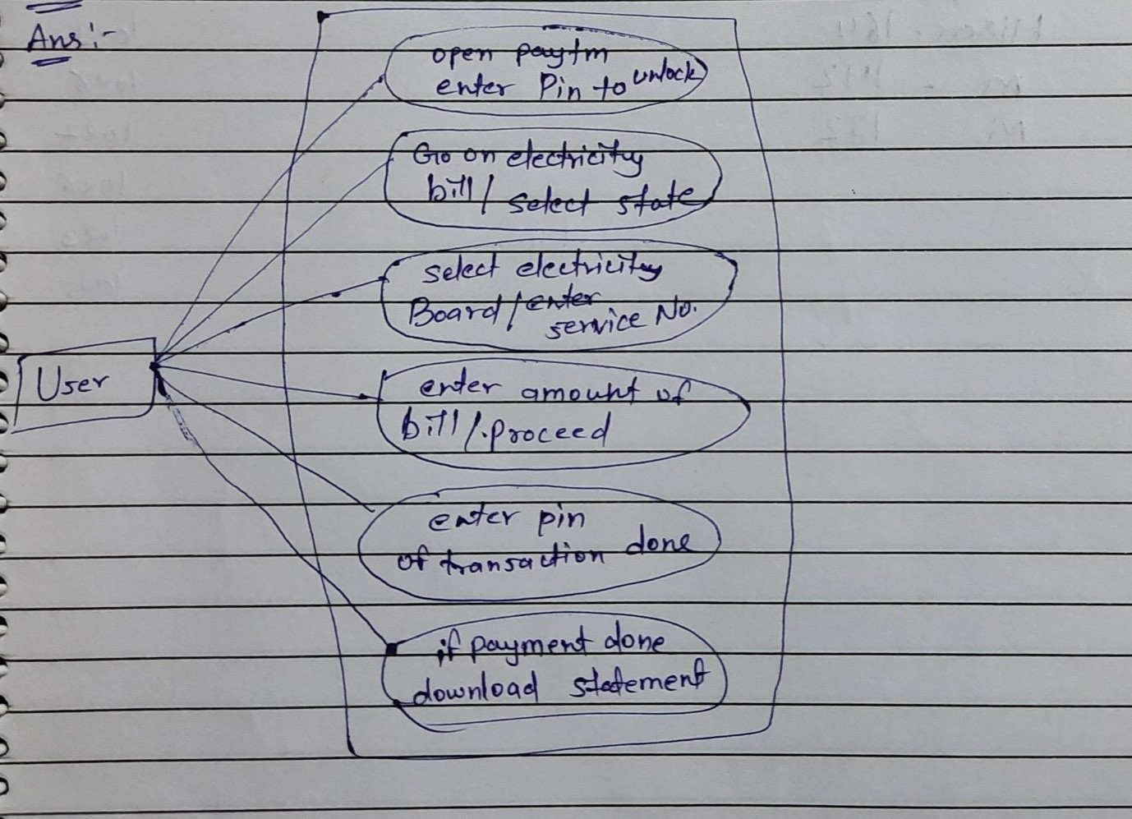

**Q16.** Write SDLC phases with basic introduction.

**Ans.** There are 6 phases in SDLC which are listed below,

1. Requirements Collection/Gathering: - In this phase we establish the customer needs and requirements for that product. Interactions with customer must be needed to understand what exactly they want. There are 2 types of requirements (1) Functional (2) Non-Functional.
2. Analysis: - In this phase we are defines the requirement of the product and how to full-fill the requirements of the customer and trying to solve problems.
3. Design: - Design phases explained by its name also. After the analysis phases we have to design the architecture, structure and implementation plan with properly completed documents.
4. Implementation: - In implementation phases now the developing team is ready to start work on that product or software after documents are given by analysis and design team.
5. Testing: - Most important phase of SDLC, testing is a part of this cycle to find the defect before the delivery of product and also the risk management.
6. Maintenance: - software Maintenance is one the of activity to fixing the defect, updating all phases again in some particular time. It is divided into 3 types (1) Corrective maintenance (2) Adaptive maintenance (3) Perfective maintenance.

**Q17.** Explain Phases of the waterfall model.

**Ans.** The water fall model is known as classical software cycle. The classical software lifecycle models the software development as a step-by-step waterfall between the various development phases.

|  |
| --- |
| Requirements |
| Analysis |
| Design |
| Implementation |
| Testing |
| Maintenance |

The waterfall model describes by the name waterfall. In this model there are developments step to follow in order one by one from starting to end and no go back and no overlap. These steps are same as SDLC.

**Q18.** Write phases of spiral model.

**Ans.** The Spiral model was divided into 4 phases which are given below,

1. Planning
2. Risk Analysis
3. Engineering
4. Customer Evaluation

**Q19.** Write agile manifesto principles.

1. Individuals and interactions
2. Working software
3. Customer collaboration
4. Responding to change

**Q20.** What is join?

**Ans.** A join clause is used to combine rows from two or more tables, based on a related column between them.

**Q21.** Write type of joins.

1. INNER JOIN: - Returns rows when there is a match in both tables
2. LEFT JOIN: - Returns all the rows from the left table and matched records from the right table.
3. RIGHT JOIN: - Returns all the rows from the right table and matched records from the left table.
4. FULL JOIN: - Returns all records when there is a match in either left or right table.

**Q22.** Explain working methodology of agile model and also write pros and cons.

**Ans.** Agile SDLC model is a combination of iterations and incremental process model with focus on process delivery and customer satisfaction by rapidly deliver of product.

Pros: -

* Promotes team work and cross training
* Functionality can be developed rapidly and demonstrated
* Resources required are minimum
* Good for environments that change steadily
* Little or no planning required
* Easy to manage
* Gives flexibility to developers

Cons: -

* Not suitable for handling complex dependencies
* More risk of sustainability, maintainability
* Depends on customer interactions
* Customer is not clear so team also not clear what to do with projects
* Transfer of technology to new team members may be quite challenging due to lack of clarity.

**Q23.** Draw use case on Online shopping product using COD.

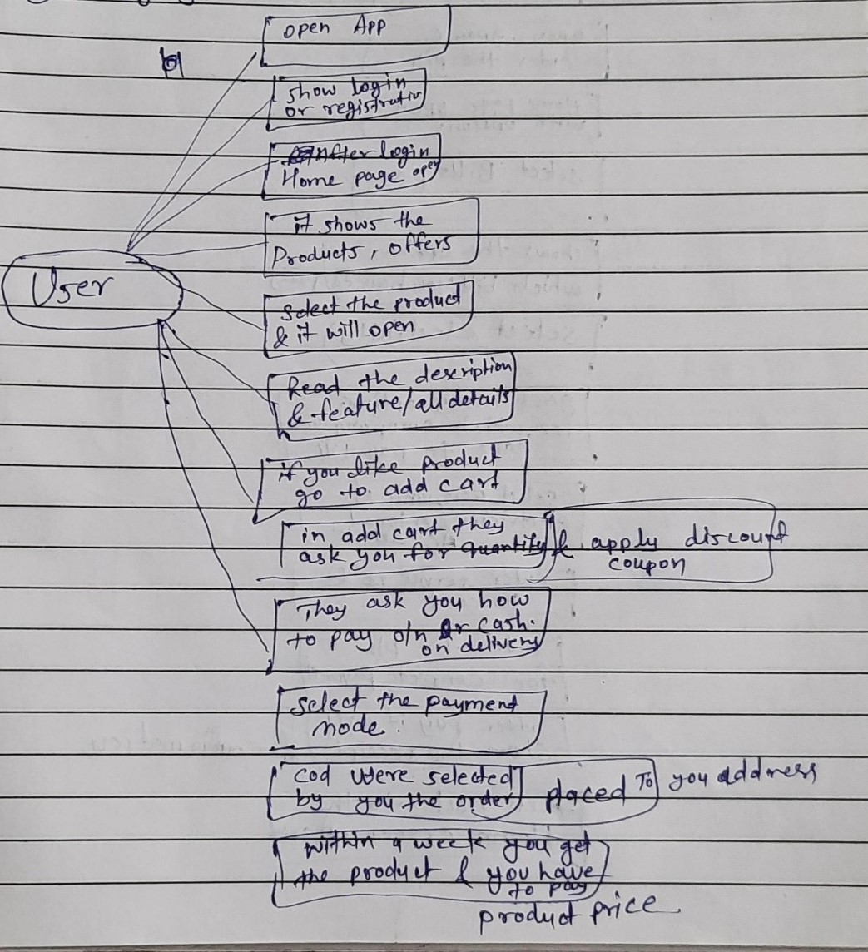

**Q24.** Draw Use case on online shopping product using payment gateway.

**Ans.**